Student Database Project

1.Introduction
This document outlines the creation of a relational database named Student Management, including two tables: Student and Enrollment.
It demonstrates how to insert data into these tables and perform various types of SQL joins (INNER JOIN, LEFT JOIN, RIGHT JOIN, and SELF JOIN) to retrieve and relate data.

2.Database and Table Creation
A database called Students was created. Inside it, two tables were created:
- Student Table: Contains basic student information (ID, name, age).
- Enrollment Table: Records course enrollments for each student.
Database Creation:
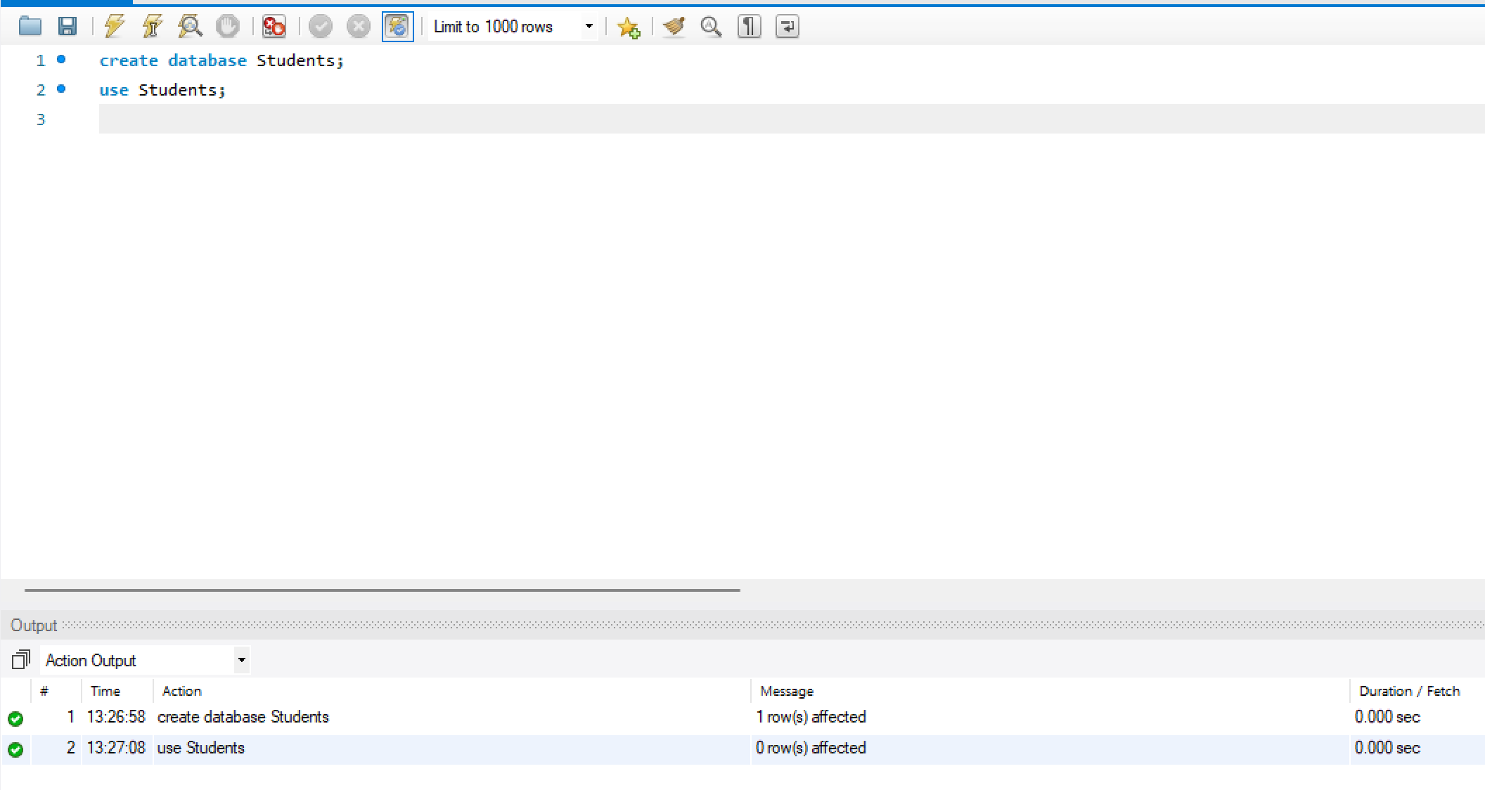

Student Table Creation:
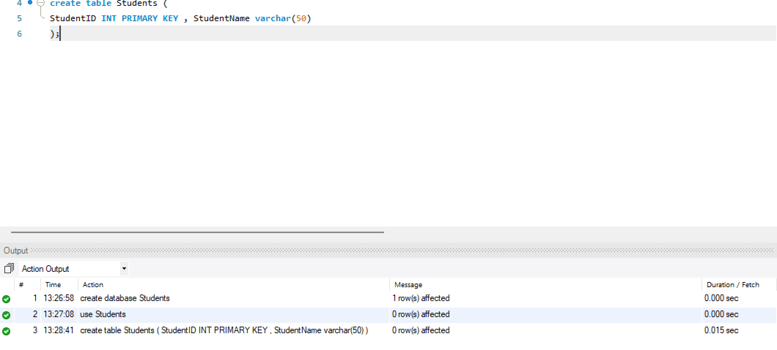

Enrollment Table Creation:
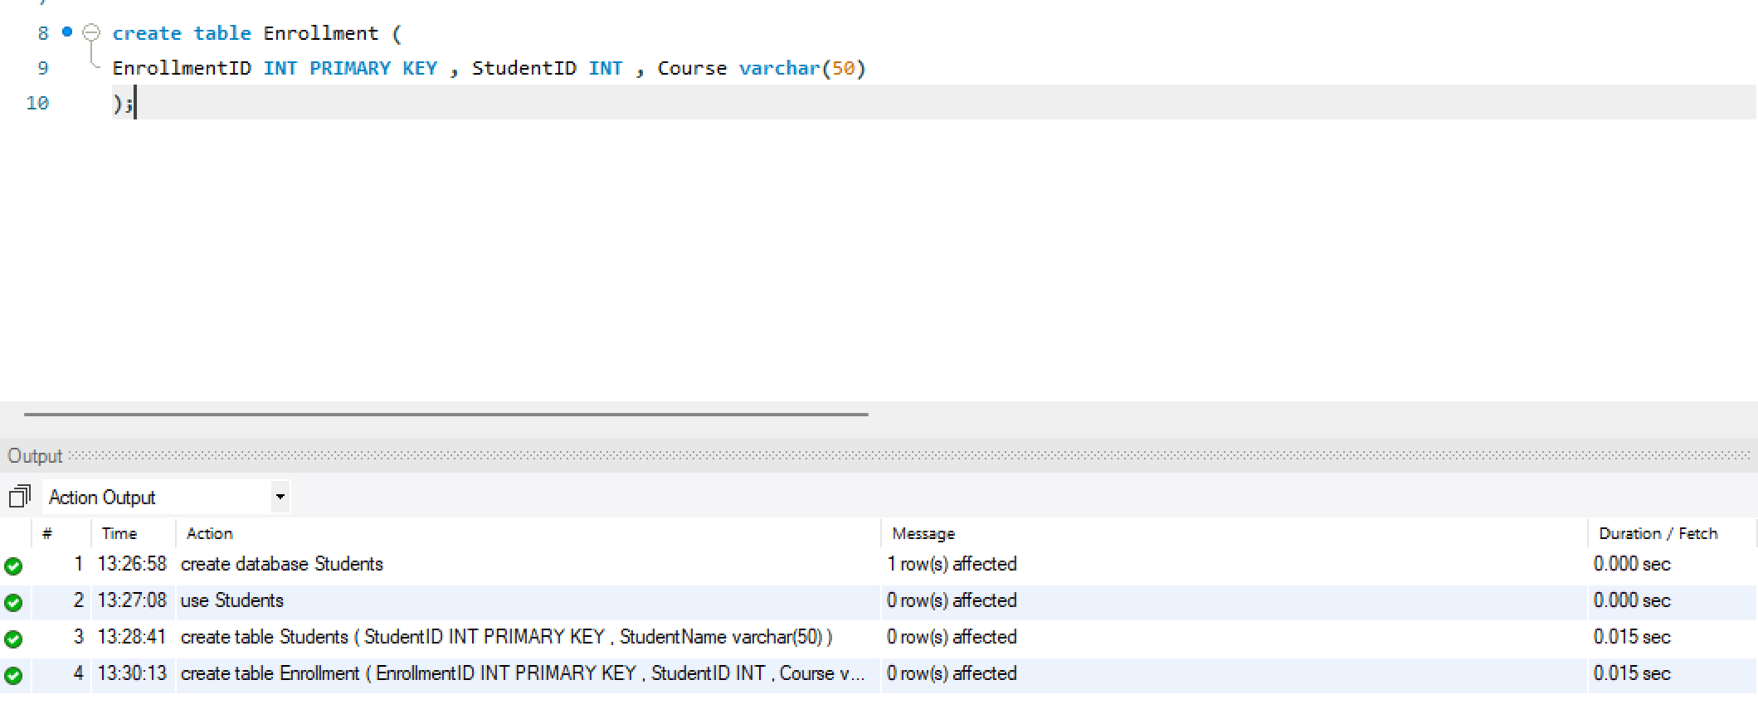

3.Data Insertion
Sample data was inserted into both tables to simulate a typical student-course relationship.

Inserted Data into Students Table:
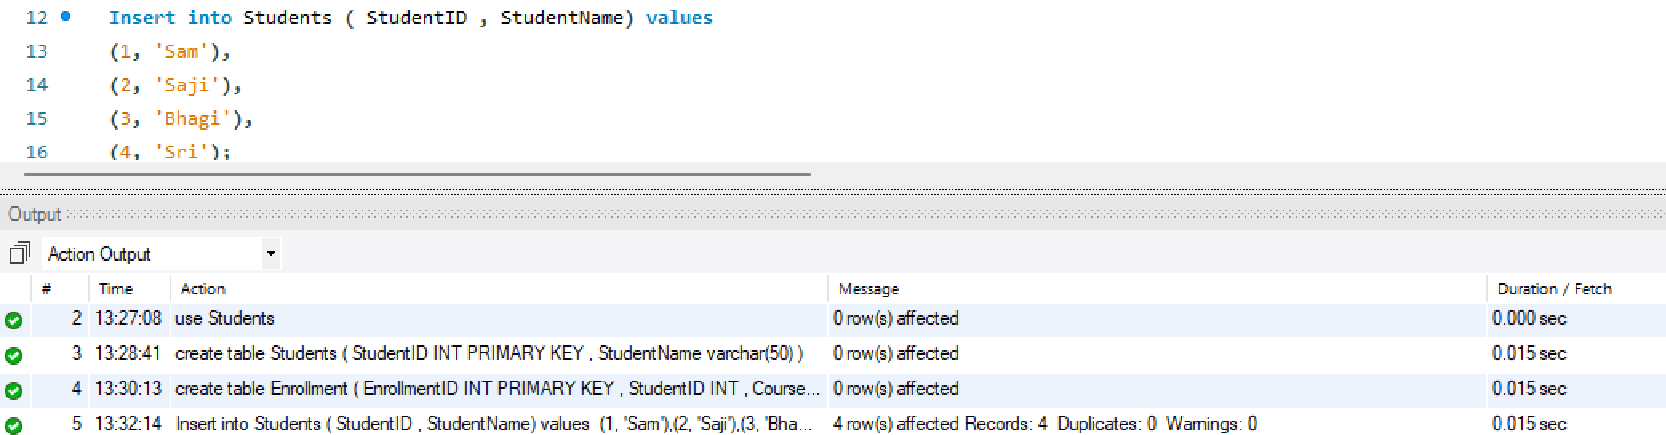

Inserted Data into Enrollment Table:
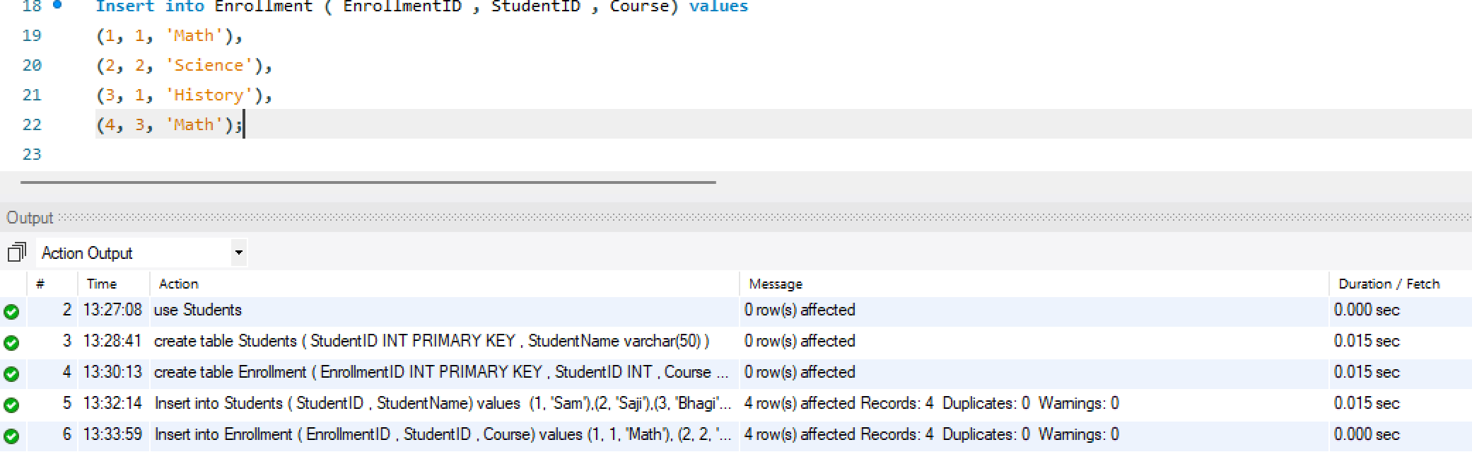

Displaying Inserted Data:
After inserting data into both the Student and Enrollment tables, I used the SELECT statement to view and verify the contents.

Displaying Students Table:
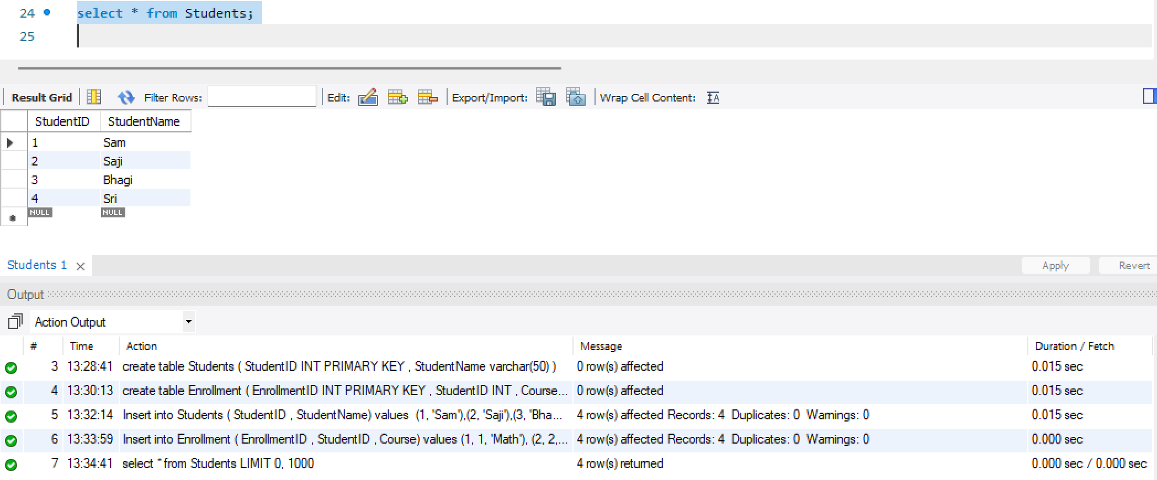

Displaying Enrollment Table:
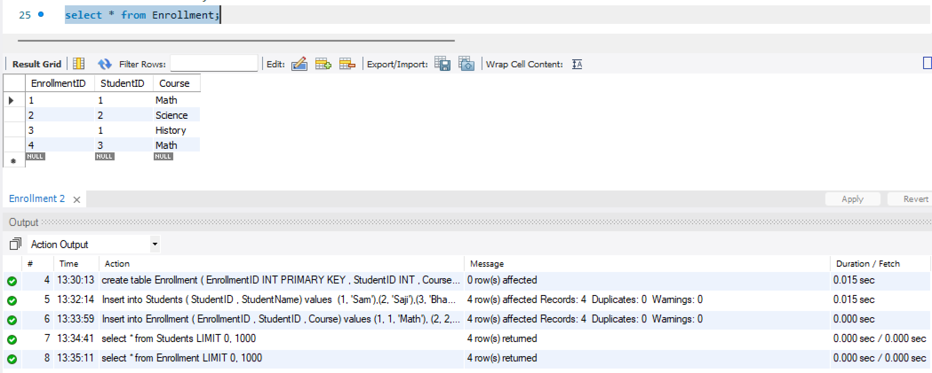

4. SQL Joins
(4.1) INNER JOIN:
Purpose: Returns only the records with matching student IDs in both tables (students who are enrolled in courses).
Performed Inner Join on Students and Enrollment Tables:
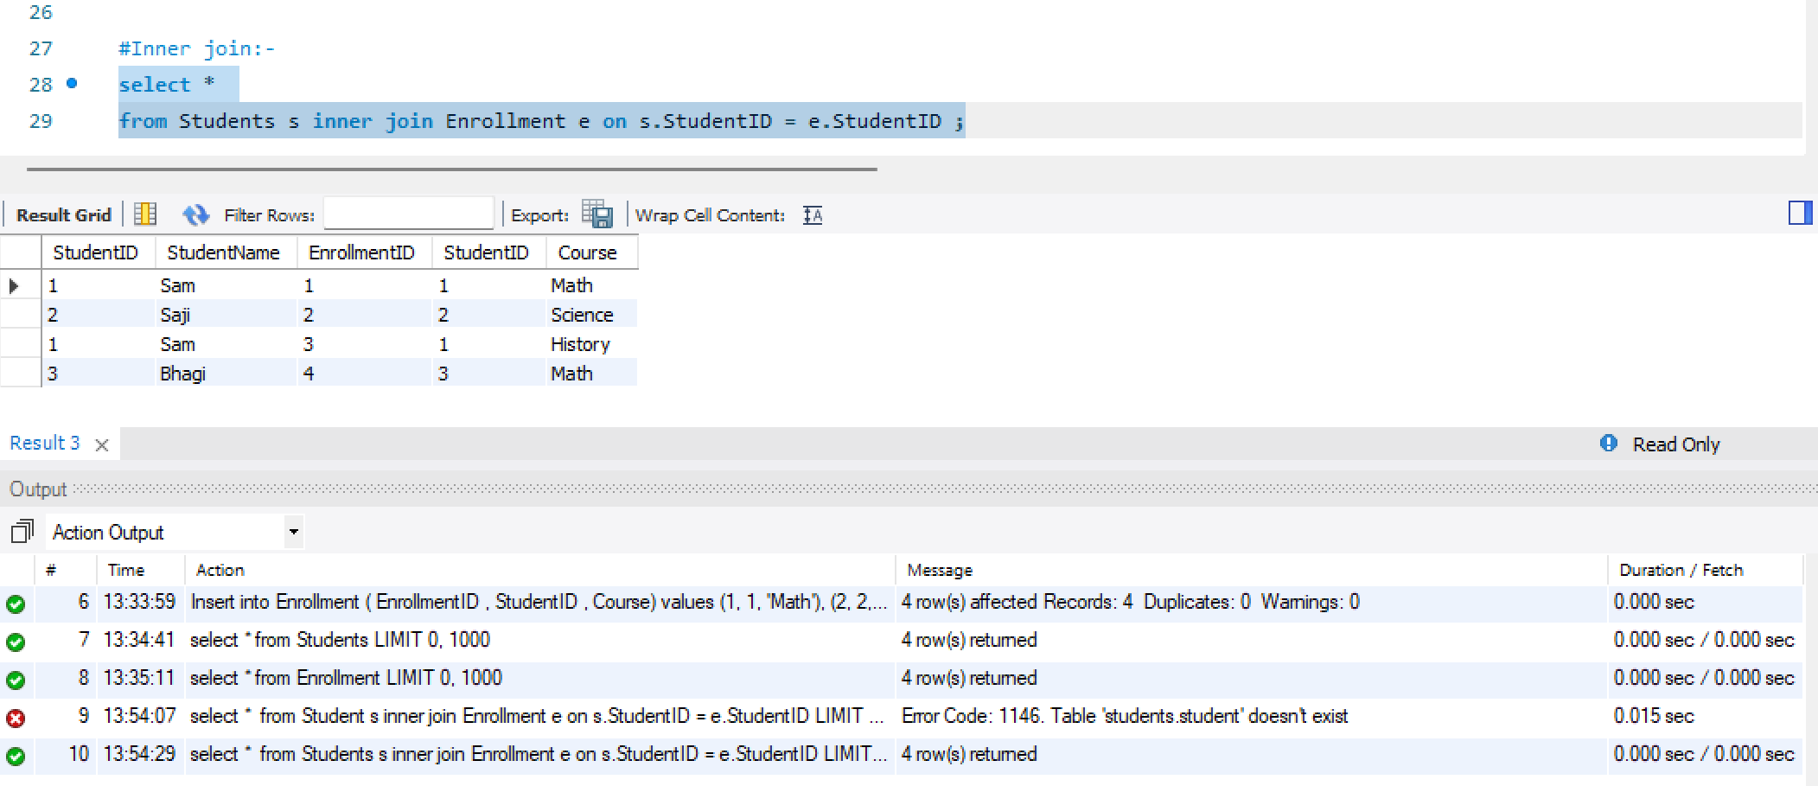
(4.2) LEFT JOIN
Purpose: Retrieves all students, including those who are not enrolled in any course (NULL course values will appear).
Performed Left Join on Students and Enrollment Tables:

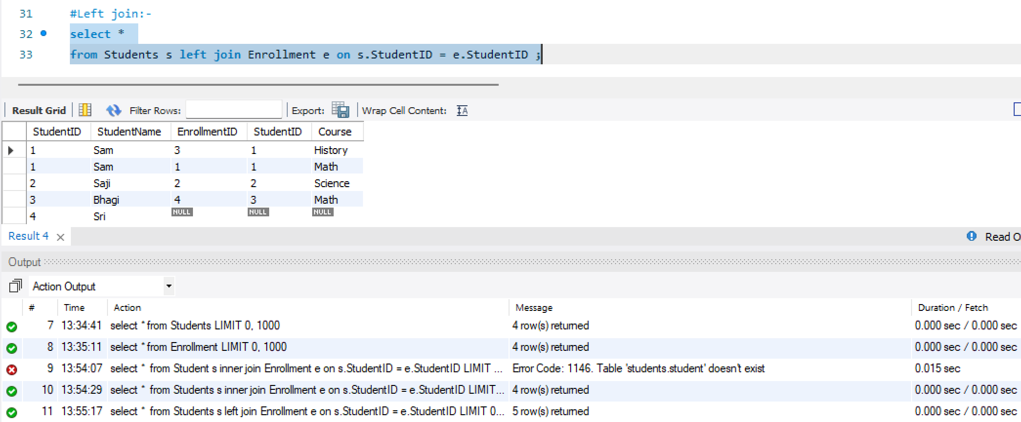
(4.3) RIGHT JOIN
Purpose: Retrieves all enrollments, including those where the student might not exist in the students table.
Performed Right Join on Students and Enrollment Tables:
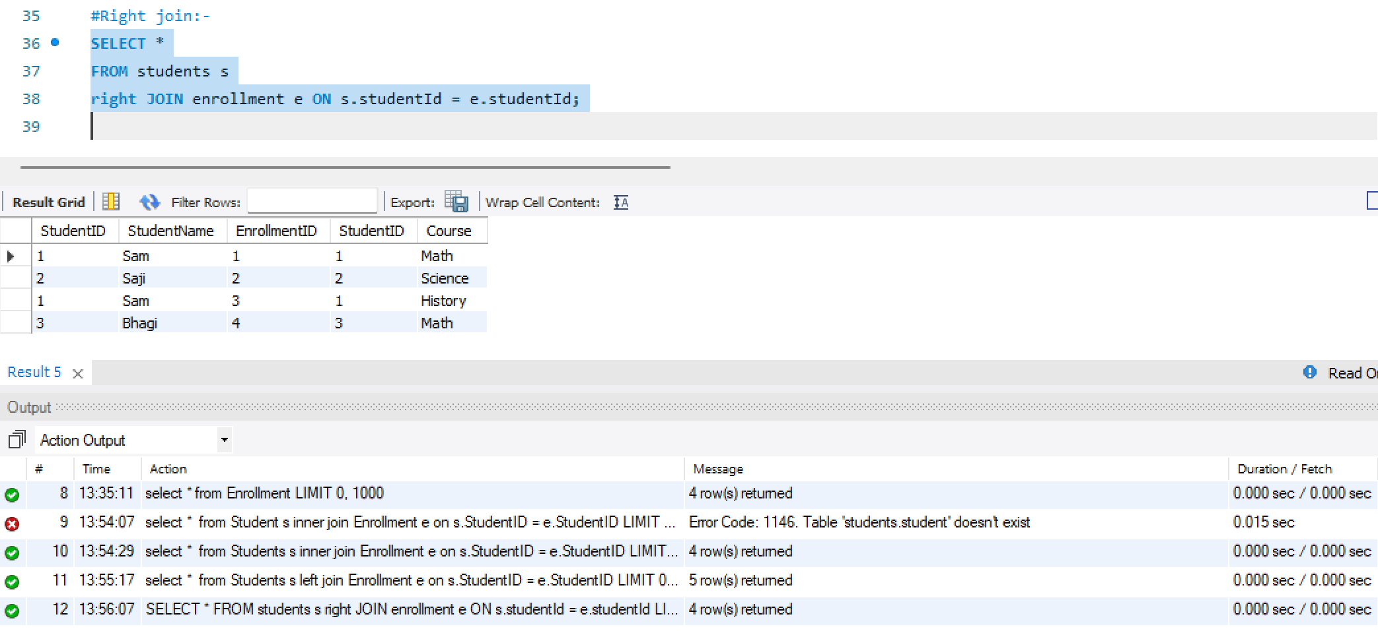
(4.4) SELF JOIN
Purpose: Finds pairs of students who share the same age using a self-join on the Students table.
Performed Self Join on Students and Enrollment Tables:
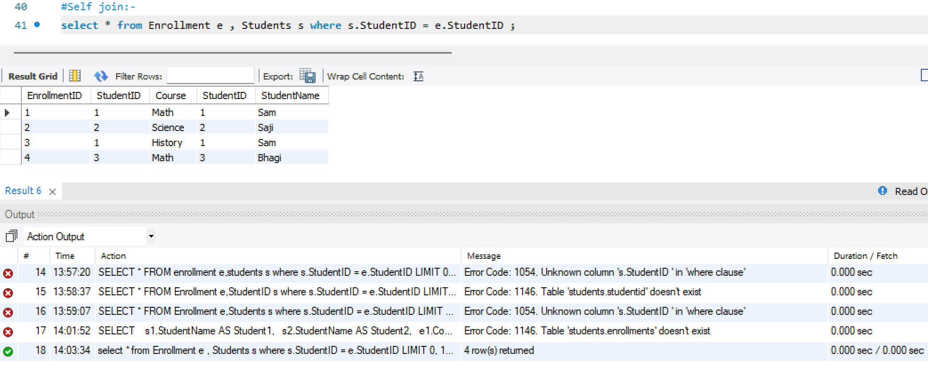

5. Conclusion
This project enhanced my understanding of relational databases and SQL join operations. It demonstrated how different types of joins can be used to extract meaningful relationships from multiple tables, helping to visualize how data is interconnected in real-world systems.

